Adobe Flash Media Live Streaming

For Broadcast
- Download Flash Media Live Encoder
- Click Here to download.
- Connect Camera or DVR to the computer.
- Introduction About flash media Encoder.

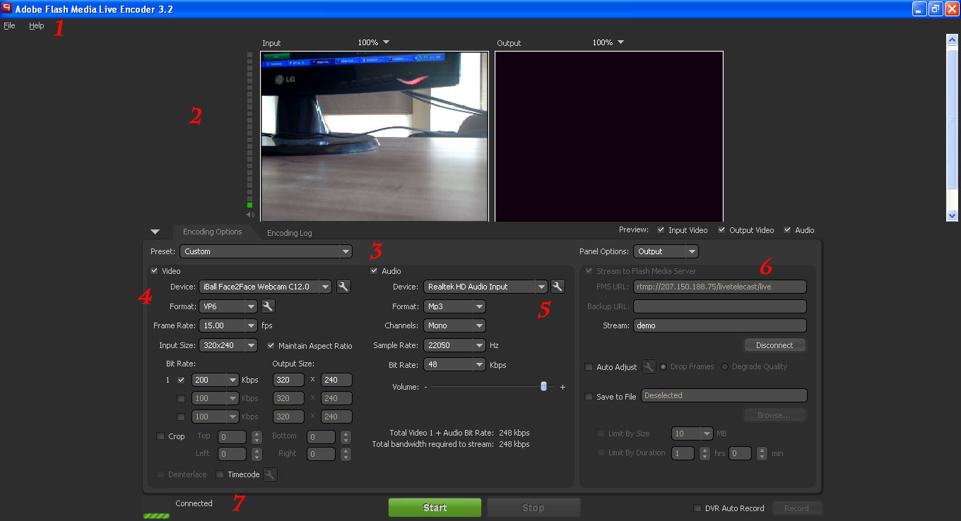

- Menus
- Preview displays: input (left) and output (right)
- Preset selector – select preset
- Video encoding settings – Select setting as you want to display viewer.
- Audio encoding settings – Select Audio setting.
- Output settings
- Control buttons: start and stop

Out Put setting
- Stream to Flash Media Server: Selected
- FMS URL: rtmp://207.150.188.75/livetelecast/live
- Stream Name: you want to add (e.g demo)
- Save to File: Deselected
- In the Output area, click the Connect button.
Note: If an error is returned, double-check all the previous steps in both this section and in the prior section.

- Click the Start button along the bottom to start encoding.
- Now open the link as below

- http://207.150.188.75/livetelecast/embed.php?id=Stream Name

Into above url replace the stream name as assign in adobe flash media encoder.

